**TABLE OF CONTENT**

1. **INTRODUCTION**
2. **THE WEB TECHNOLOGIES**
3. **ACCESSIBILITY**
4. **WEBSITE DOCUMENTATION**
5. **WEBSITE DEPLOYMENT**
6. **REQUIREMENTS ENGINEERING**
7. **CONCLUSION**
8. **REFERENCES**
9. **INTRODUCTION**

On the 17th of January 2023, Mr. Hyna contacted RFAK Ltd requesting that the company wants a website design. Sarah, being a web designer in RFAK Ltd was appointed to arrange an appointment with the client and other stakeholders involved, in other to gather information using workshop elicitation technique The appointment is for 2nd of Feb. 2023.

Before going for this appointment, Sarah has prepared and typed out a few relevant questions on Microsoft forms, to be asked on the appointment.

After gathering the data from the client, Sarah will then proceed with the design of the webpage using Visual Studio Application.

After designing the company logo below, the website creation commenced.

1. **THE WEB TECHNOLOGIES**

To create a website for Night Music Ltd, Sarah intends to use HTML, CSS and JAVA Script.

HTML (Hyper Text Markup Language) being the standard markup language for creating Web pages, can be used to describe the structure of a Web page.

HTML consists of a series of elements which gives command to the browser on how to display the content. Here you have the Heading, Title and Body of a webpage, which can be used with tags.

The Head section of an HTML element is where the links from a Bootstrap and CSS is coded. Also found is the Title of a website page. This sections or tags starts with < and ends with />. Without the closing element, the command cannot function.

CSS (Cascading Style Sheets) is the language used to style a Web page.

This describes how HTML elements are to be displayed on screen or paper.

It can control the layout of multiple web pages all at once.

While JavaScript is a programming language used in programming the language of the Web.

These 3 Technologies, though has different pages, are linked together on the head section of HTML page, in other to reflect on the webpage. These codes have been used as they command the styling of a website.

1. **Responsiveness:**

Having a responsive website makes a webpage easy to use on any device, since we live in a world where not so many people does not have a laptop handy, people easily browse on their phones from where ever they are, and creating an e-commerce website entails that the company would want their customers to purchase their products from anywhere they are, be it office, home, school or on the road.

This is where a Bootstrap comes in, Bootstrap Link from W3School.com makes a website automatically responsive, in achieving this, a @media tag also came into play on the CSS coding page.

1. **Multipage Website:**

The webpage consists of 4pages, this was implemented because having multiple webpages makes it easy for users to navigate through the webpage, users can easily navigate, and the current page will have just the information they need rather than interrupting with other information that they do not want at the moment.

This was achieved by using the unordered list element <ul> on the html code where the ordered list element <li> and the anchor <a> element with its href attribute which links these pages together are listed, as shown on the image below.

1. **E-Commerce Functions:**

Implementing E-commerce functions on a webpage ensures customers can find **everything needed in one place**, without a necessity to even get up from the couch. This is probably one of the greatest advantages of online shopping.

1. **ACCESSIBILITY:**

Using Allyproject.com (A11yproject.com, 2013), a website accessibility was done to ensure the website meets accessibility standards. This helped with the standards required to make a website accessible by everyone who logs on to it, but especially for disabled people, like the lang attribute on the html element with helps with the type of language to be used on a webpage.

As Night Music Ltd plans to add Song Mix to their website product page in the future, this site has helped in knowing that transcripts should be available on audio files attached on a website page.

Below are the screenshots of the accessibility checklist from Alliproject.com.

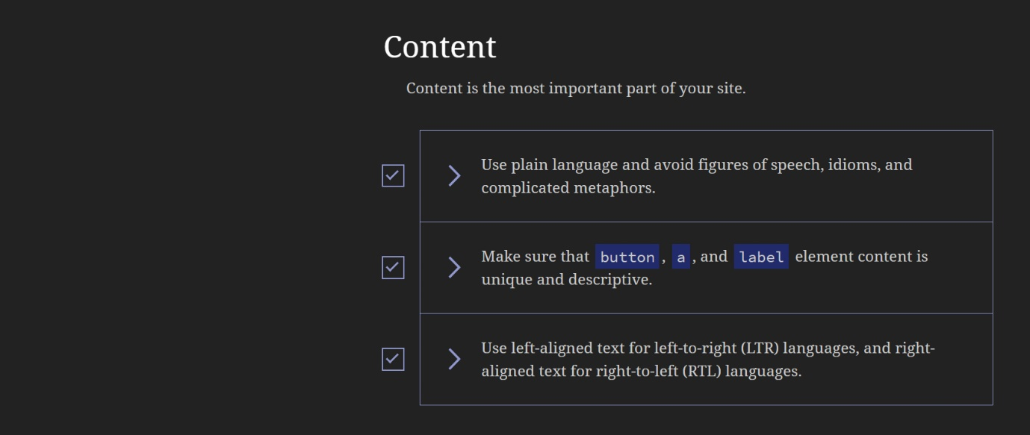

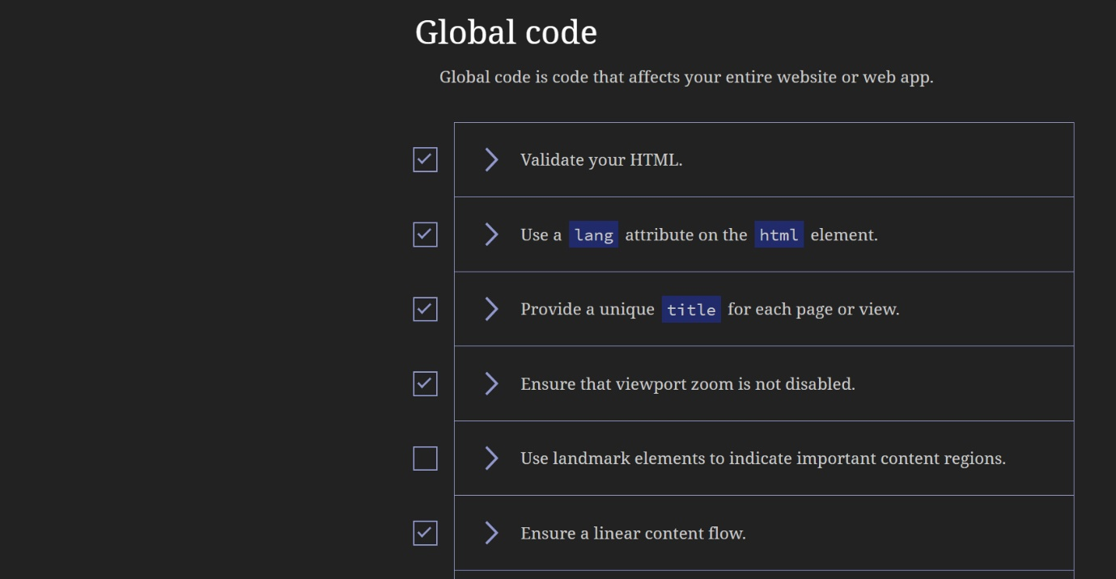

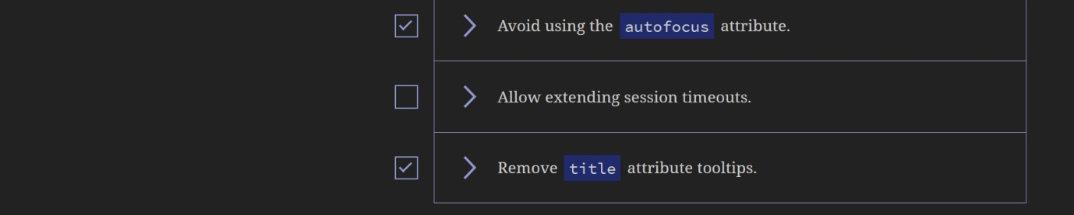

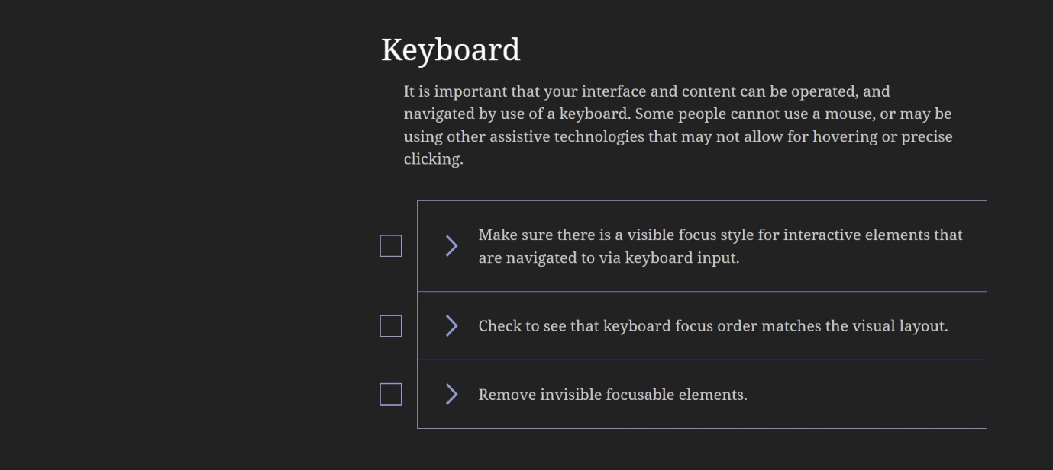

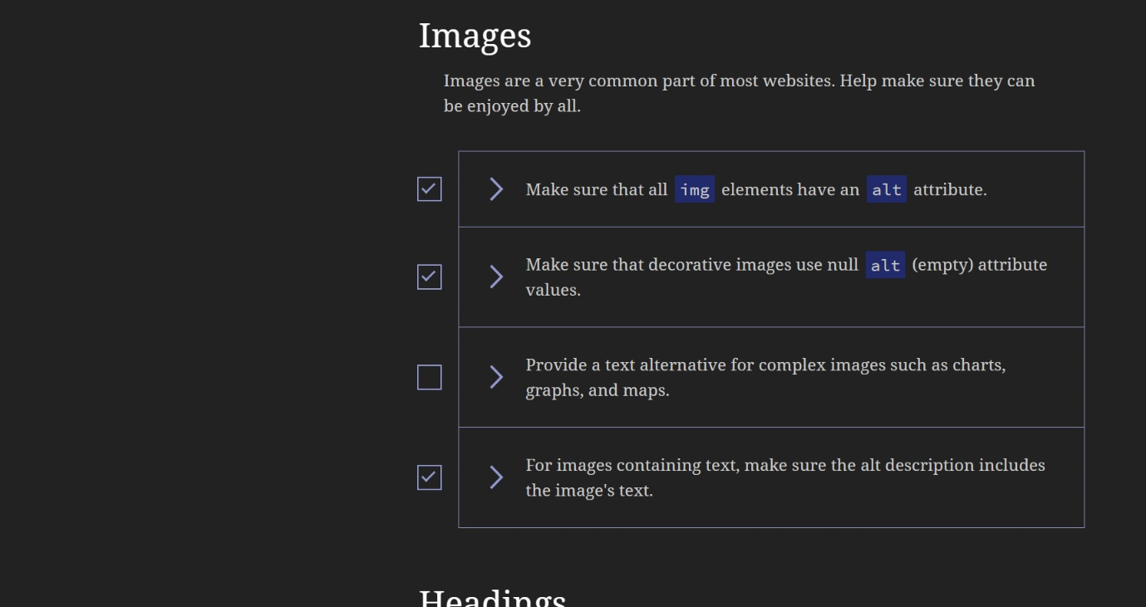

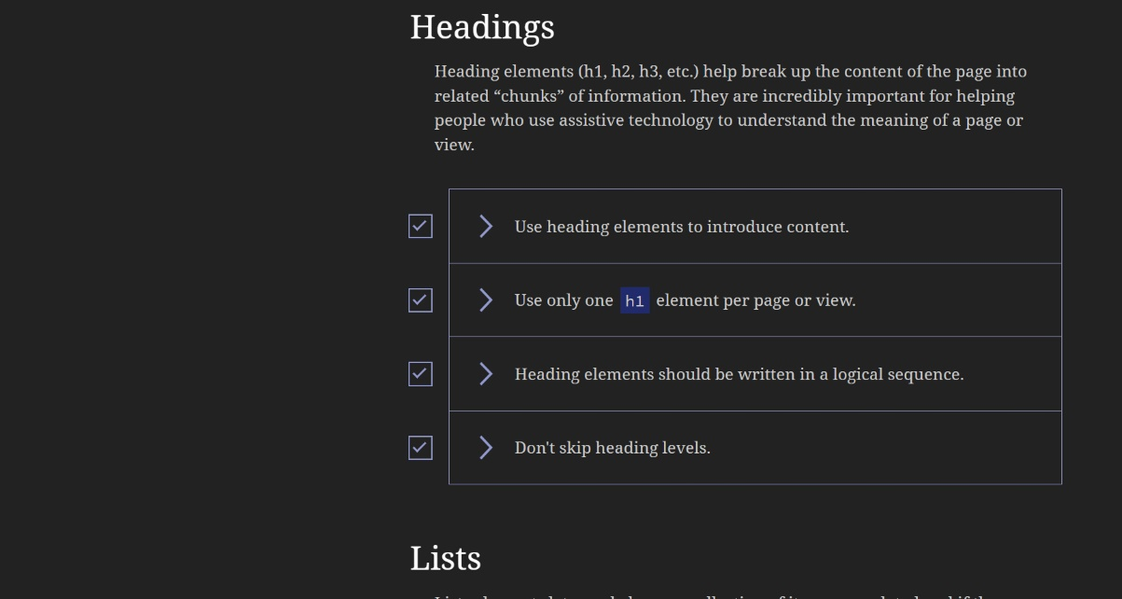

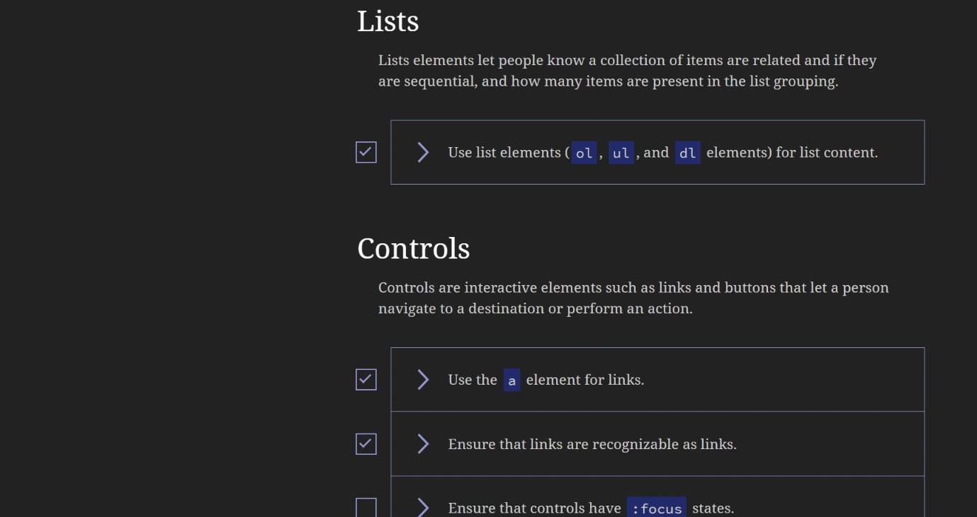

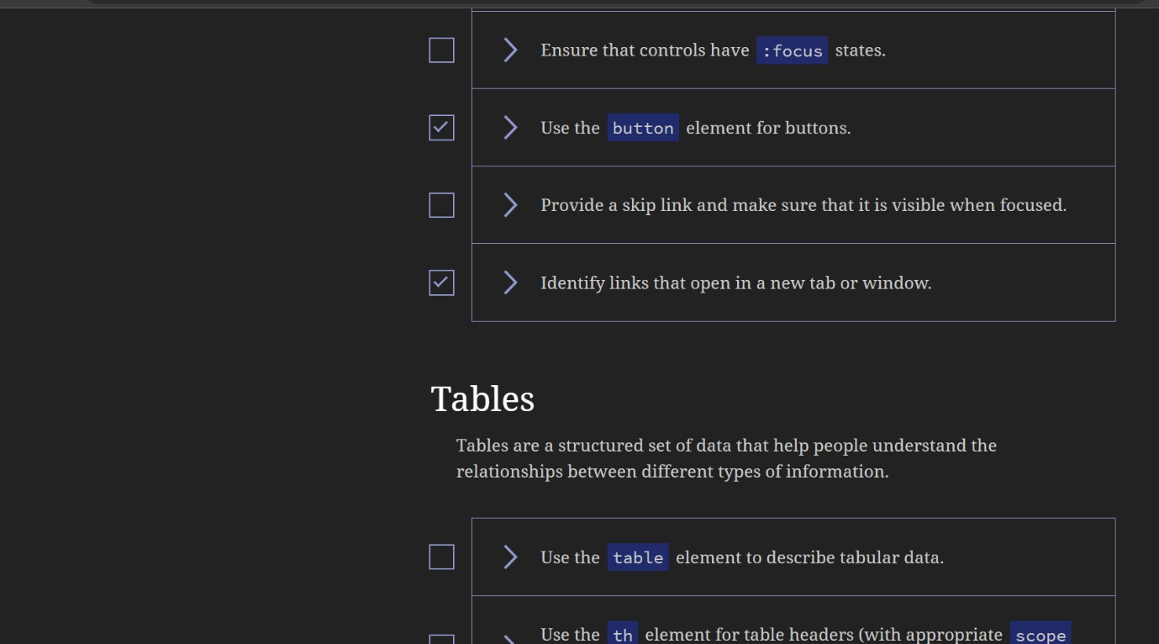

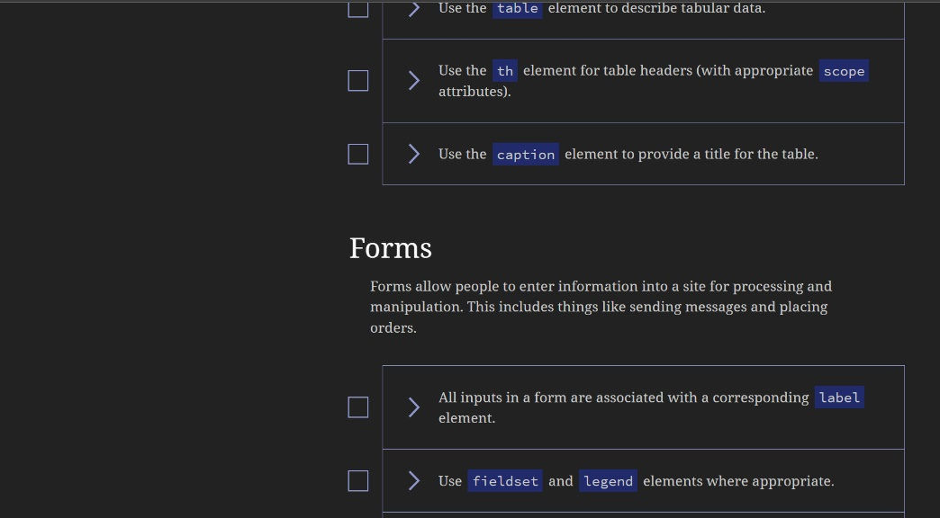

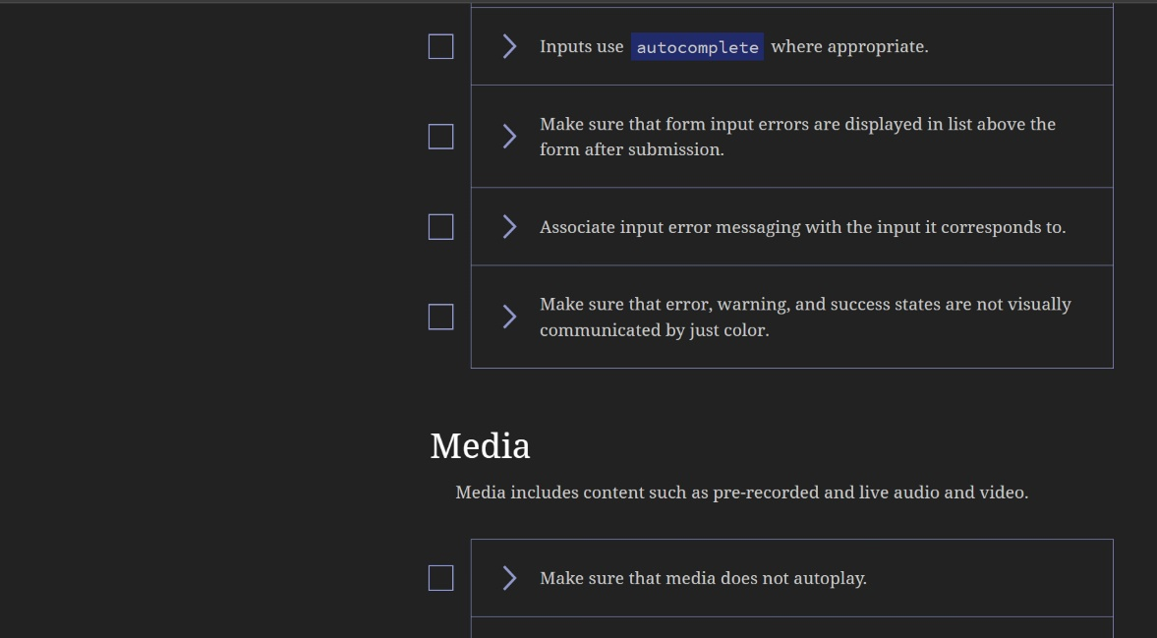

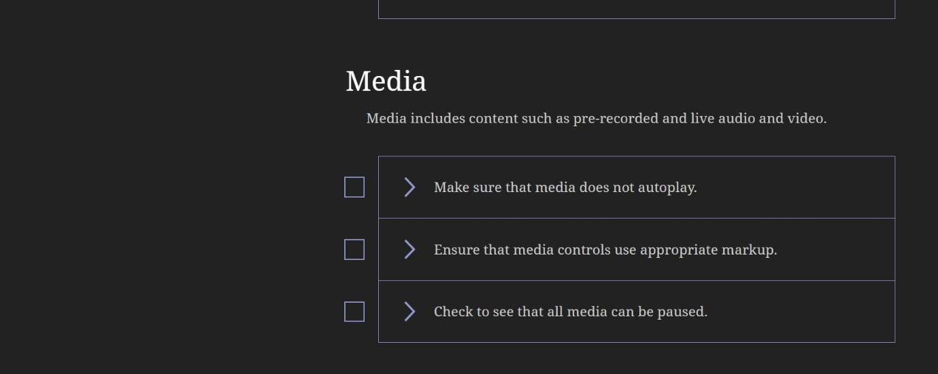

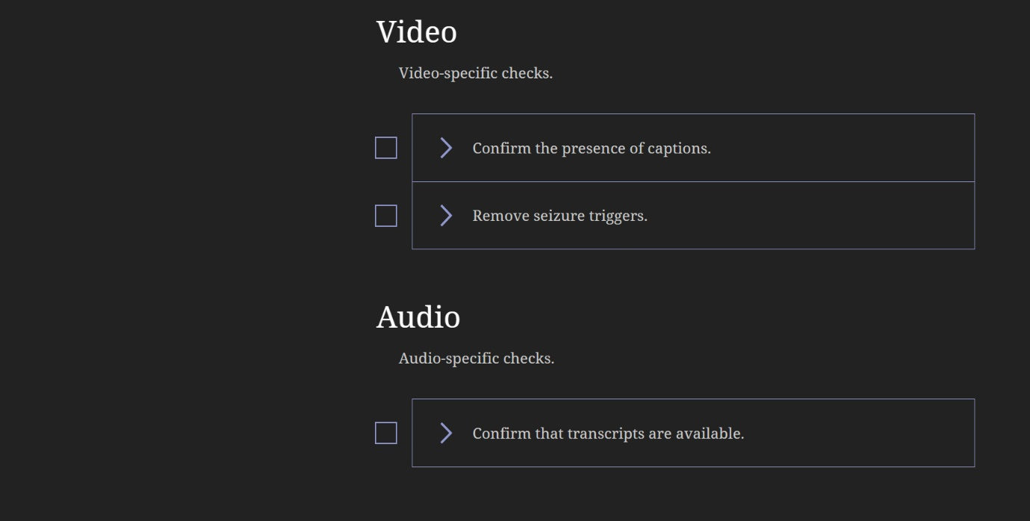

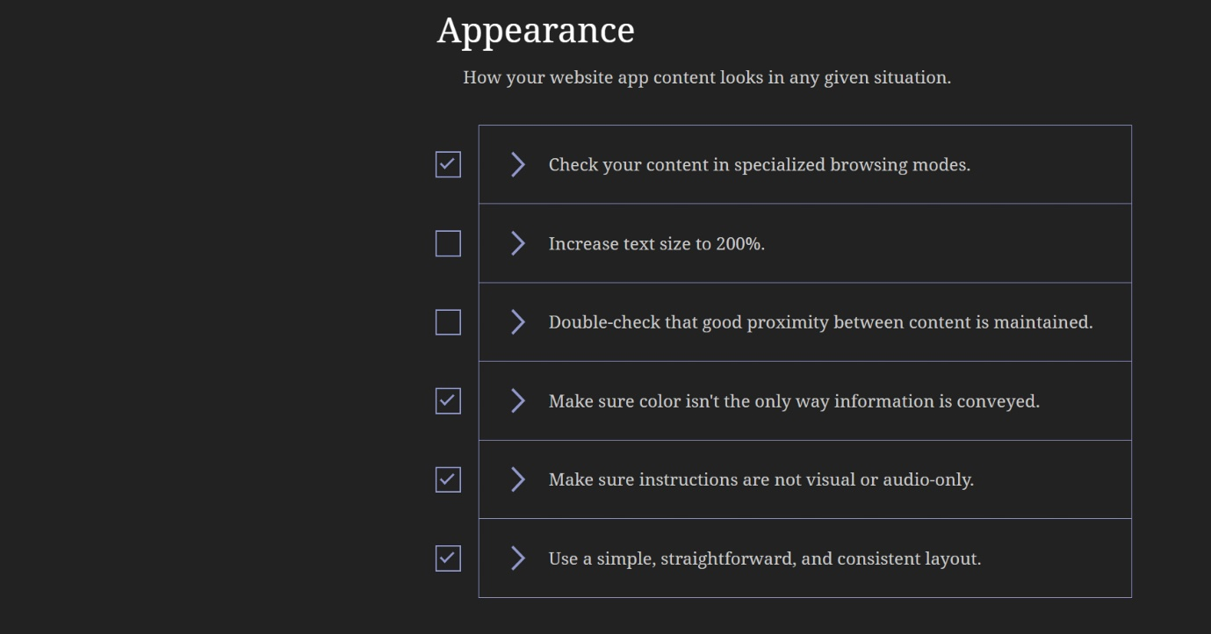

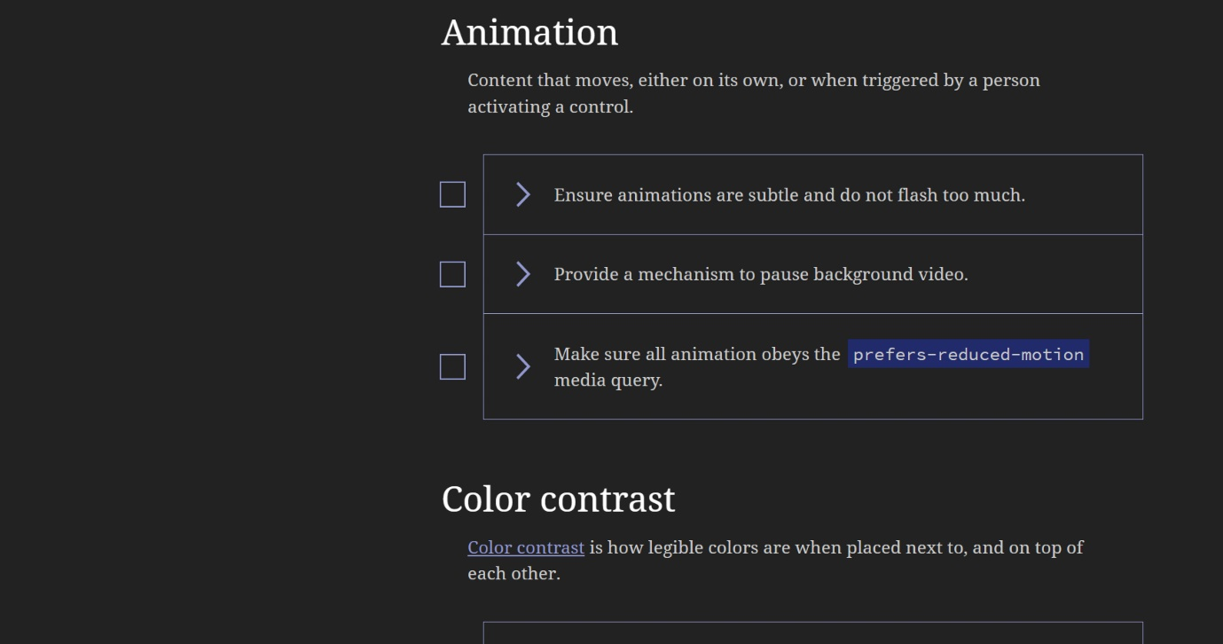

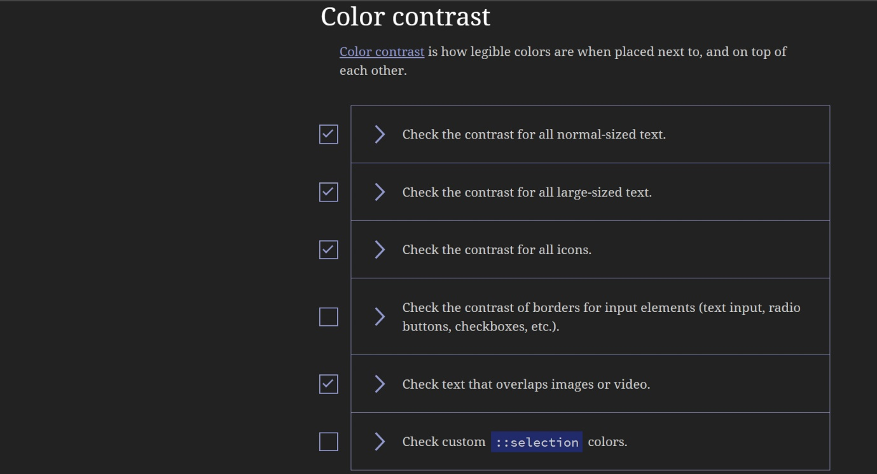

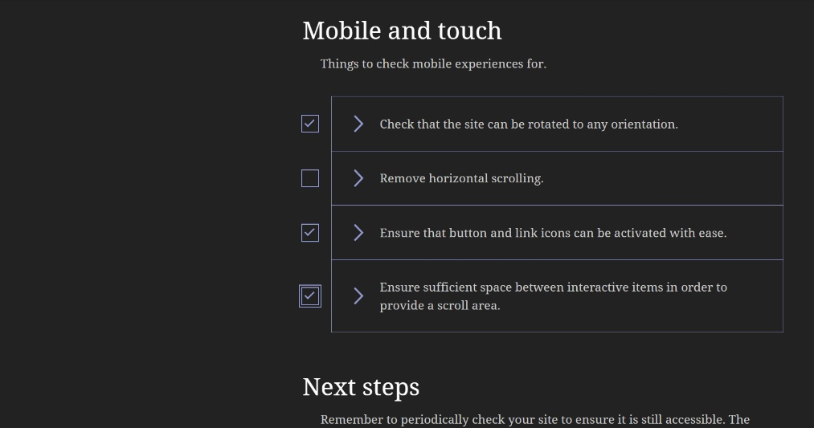

This checklist has helped in making sure the website meets the accessibility stand as the met as shown by the marked items.

According to Usability.gov *“By making your website accessible, you are ensuring that all of your potential users, including people with disabilities, have a decent user experience and are able to easily access your information.  By implementing accessibility best practices, you are also improving the usability of the site for all users.”* (Usability.gov, 2023).

Making website pages accessible does not only benefit disabled persons but also people without disability.

To achieve this, it Is important that a web developer puts into consideration the use of colours, audio, video and images; font family used in the design.

Also making sure a whole website is keyboard-friendly which allows users to access every part of the site with ease.

The Night Music Ltd webpage consists of an accessible color palette of purple(#9900cc) and black(#000000) which makes it accessible for people with colour vision deficiency.

And Popping font from GoogleFont.com (Google Fonts, 2023), was used.

1. **WEBSITE DOCUMENTATION:**

**The Head:**

The features of this website include the Head section of the HTML code page which consists of the links and Title Tag of a website.

The picture below shows a screenshot of the links used for the webpage.

Font Icon Link for all the Icons used on the webpage from fontawesome.com (Solid, 2023).

A link from Swiper.com was also used to enable the NEW ARRIVALS HTML Page to swipe both ways.

According to w3school.com *“With Bootstrap, a navigation bar can extend or collapse, depending on the screen size.”* (W3schools.com, 2023), reason why a link from W3school.com was used, these links consist of the HTML and JavaScript Bootstrap link.

Here is also a CSS link that links the Homepage to the CSS, which styles it.

This part of the code can only be see from the beauty of the website and not as a text.

**The NavBar:**

The image below shows the Header tag <Header></Header> on the Body <Body></Body> Section of the HTML Code Page, which consists of the NavBar features like the company logo, and the Unordered list tag <ul></ul> that links the 4pages of the website together.

**The NavBar - Icon Bar:**

The Image below shows the icon tags links from Fontawesome.com (Solid, 2023), used for the Menu, Search, Cart and the Login Bar, found on the Body of the HTML code page. These was implemented using the div class tag <div></div>

The screenshot below show the javascript code where the the “Let” keyword was used to introduce the document.querySelector variable in styling the icons on the Navbar.

The Images below shows a screenshot of what the NavBar looks like when a user logs on to the webpage.

**Home section**

The Homapage of Night Music Ltd website, this page introduces a user to what the website is all about, the type of product the company sells, it also contains the footer below, where a user can easily navigate and get all the contact and addresses of the company.

The screenshot below shows the Home section of the webpage on the HTML code page, the section tags was used here <section></section> to divide the features of the homepage body from other sections on the home page.

The span tag <span></span> was used to highlight and make the writeup between it different from others.

HTML:

CSS:

CSS page where the styling of the HTML is done, here is also a background image of the homepage, here the classes of each section or class was used to identify the element or tag being styled.

Below is how a user sees the above codes (HTML and CSS) on the webpage.

HomePage background image was gotten from unsplash.com (Unsplash, 2023)

**Footer section**

Below is a screenshot of the html footer section of the homepage.

A section tag <section></section> was used to separate the footer from the main information on the homepage. And on each div class <div>, there is an ordered list tag <ol> used to list each box of the company contact details.

Below is the CSS code page that styles the code in the HTML, here the classes of each section or class was used to identify the element or tag being styled.

**New Arrivals Page:**

Just like the Homapage, this page has a header <header> tag in the Body section which consists of the Navbar pages and icons, and also the footer section below it as explained on the homepage.

The screenshot below shows the HTML codepage of this;

This page has a div tag named (Home-2) to controls all the image in the body of page. All the pages are linked to one CSS code page, making it easy for the website designer to link through.

The autoplay effect was gotten from Swiperjs.com (Swiper, 2023) to make the images swipe both ways.

This page displays all the new products that the company has in store for sale.

Below is a screenshot that show how a user views the above codes.

**The Product Page:**

Using the div, section and heading tag <div>, <section>, and <heading> a section was created to have only the images of the products sold by the company.

With a link from FontAwesome.com, the cart and star icons were added on each product.

This page shows all the products the company has in store for sell. Below is the screenshot of how a user views this page.

This page also contains the footer below it where a user can easily navigate to and get all the contact and addresses of the company.

It has a div tag named (Home-2) to controls all the img tag <img>, the <i> and thee <h1> in the body of page.

Product Page Body Section, Bootstrap Grid Basic Example from w3school.com (W3schools.com, 2023)

The images from this page were downloaded from unsplash.com (Unsplash, 2023).

**About Page:**

This page talks about the company’s **Vision, Mission and Achievement** over the years.

With the div tag <div> a class was created to develop the containers having each information on the boxes.

Below is the HTML code page.

Below is the CSS code page, here a <hover> tag was used to add a style to each box when a user clicks on it.

Below is how a user views the codes above.

Like other pages, this page has a footer below where users can contact the company.

**HTML/CSS Validator**

Using validator.w3.org (W3.org, 2022), a checklist was made to ensure the designed website meets the validity standards.

The usage of this made it easy to checklist a website’s standards because as a website developer, it is important that these validations are met to ensure that websites are accessible to people with disabilities; the produced results (screenshots) can be found below.

Screenshots of the validity result after check-listing the accessibility of the homepage website.

Validation Error:

After correcting the errors found, below is a screenshot without errors, thereby making this page accessibility validated.

Below is a screenshot of the CSS page with 4 errors after checklist was made with W3.org validator.

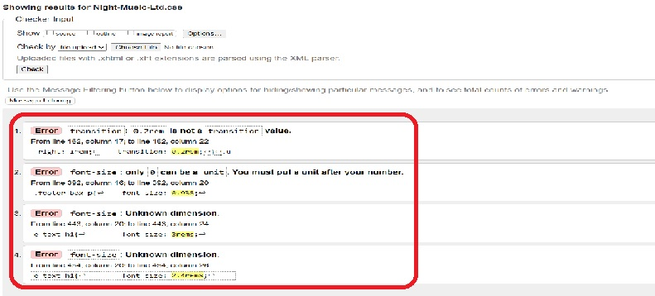

Below is the screenshot of the CSS page without errors after a checklist was made with W3.org validator.

1. **WEBSITE DEPLOYMENT**

To deploy a website via Git makes it possible for a developer to deploy the changes made on the website codes (HTML, CSS and JAVASCRIPT) to an environment where it will go live or developed – The use of Git creates a link that a user/the developer can use to view the codes that have been created on the web technology pages. It is usually made private as this cannot be allowed to be seen by the public till a web developer is sure that the website is ready to be made public.

Below is a Git Link to the Night Music Ltd website created using Github.com (GitHub, 2023)

1. **REQUIREMENT ENGINEERING**

There are various techniques use in eliciting information from clients, which helps a business personnel/a web developer to know what a client wants and how to implement it.

Workshop Technique is one of this is seen as a meeting with a number involved. According to brcommunity.com*, “A workshop is a structured meeting in which a carefully selected group of stakeholders and content experts work together to define, create, refine, and reach closure on deliverables (such as models and requirements) that represent user requirements.”* (Gottesdiener, 2017). Helping all the stakeholders involved in the project to air their view on any decision being discussed. Also creates a room for a client to dispute the ideas of an expert while taking a lot of time from both parties especially from the expert.

**Interview Technique** Is another way an elicitation technique can be conducted as it involves having a relaxed communication which involves questions with a client. It can be done more than once if needed, as a follow up discussion between a client and an expert.

According to businessanalysmentor.com, *“Interviews involve asking questions, listening to the answers, and asking follow-up questions. Interviews can be done one-on-one, but they can also be done in a small group setting if you’re careful to get all the perspectives out.”* (Nicholas, 2021).

Interview helps an expert know what a client has in mind, saves time while on the project; helps the records. Client’s limit the creativity in the mind of an expert. Take various medium like in-person, virtual/online, it can still be time consuming.

With **Observation Technique,** an expert can assess the performance of a company he wants to create a project for, after planning out questions to ask; the collected data helps in the project swiftness.

According to businessanalyslearnings.com, *“The observation technique is an effective means of deciphering how a user does their job by conducting an assessment of their work environment.”* (Famuyide, 2013).

With this, an expert understands the terminologies of a company and how things work, assimilation of information is done, thereby giving an opportunity for idea creation; causing an expert not to have a relaxed discussion with the stakeholders involved thereby creating an avenue for mistakes or creating rooms for corrections or a client rejecting a finished project.

**Document Analysis** provides a web developer with a company document that contains all that an expert need to proceed with a project, an expert study this document, uses it to gather all the required data for the project, thereby saving time for both parties, but limits what an expert would have loved to ask from a client. This helps an expert to design a plan outside of the given requirement, giving room for more creativity. This also creates room for follow-ups.

**Surveys and Questionnaires is not the least as some persons prefers this type of technique as it helps** the parties involved to be contacted remotely no matter their location, thereby reaching a team conclusion.

According to businessanalytsmentor.com, *“The survey elicitation technique is the preferred elicitation technique when faced with many stakeholders or when stakeholders are geographically dispersed, and you need to gather the same information from them.”* (Nicholas, 2021), saving time for both parties. Helps all the stakeholders involved to air their view separately without the other interruspting, but at the end, a team delivery is achieved.

1. **Formal List of Questions Using MS Form**

1. **CONCLUSION**

As a Front-end developer, it will be important to use the information learnt so far to become more proficient in coding languages such as HTML, CSS and JAVASCRIPT; understanding the server-side as this knowledge will help develop web page and structure, develop features to enhance the users’ experience, make sure the pages I design are optimized for best speed and scale.

And building aa reusable code for future use.

While making sure the created webpages are responsive, it is important to make it accessible to all users.

1. **REFERENCES**

* A11yproject.com. (2013). *Home - The A11Y Project*. [online] Available at: https://www.a11yproject.com/ [Accessed 16 Feb. 2023].
* W3.org. (2022). *The W3C Markup Validation Service*. [online] Available at: https://validator.w3.org/ [Accessed 15 Feb. 2023].
* Usability.gov. (2023). *Accessibility Basics | Usability.gov*. [online] Available at: https://www.usability.gov/what-and-why/accessibility.html#:~:text=By%20making%20your%20website%20accessible,the%20site%20for%20all%20users. [Accessed 15 Feb. 2023].
* Google Fonts. (2023). *Google Fonts: Poppins*. [online] Available at: https://fonts.google.com/specimen/Poppins?query=poppins [Accessed 16 Feb. 2023].
* Solid, C. (2023). *User Classic Solid Icon | Font Awesome*. [online] Fontawesome.com. Available at: https://fontawesome.com/icons/user?s=solid&f=classic [Accessed 9 Feb. 2023].
* W3schools.com. (2023). *W3Schools online HTML editor*. [online] Available at: https://www.w3schools.com/bootstrap5/tryit.asp?filename=trybs_navbar&stacked=h [Accessed 8 Feb. 2023].
* Swiper. (2023). *Swiper Demos*. [online] Available at: https://swiperjs.com/demos#autoplay [Accessed 16 Feb. 2023].
* Unsplash (2023). *100+ Headphone Pictures | Download Free Images on Unsplash*. [online] Unsplash.com. Available at: https://unsplash.com/s/photos/headphone [Accessed 8 Feb. 2023].
* Gottesdiener, E. (2017). *Eliciting Business Rules in Workshops (Part 1) : Features : Business Rules Community / Business Rules Journal*. [online] Business Rules Community - BRC. Available at: https://www.brcommunity.com/articles.php?id=b121a#:~:text=A%20workshop%20is%20a%20structured,requirements)%20that%20represent%20user%20requirements. [Accessed 19 Jan. 2023].
* Nicholas, J. (2021). *9 Elicitation Techniques Used by Business Analysts – Tips and Guidance*. [online] BusinessAnalystMentor.com. Available at: https://businessanalystmentor.com/elicitation-technique/#:~:text=It%20is%20one%20of%20the,get%20all%20the%20perspectives%20out. [Accessed 19 Jan. 2023].
* Famuyide, S. (2013). [online] Businessanalystlearnings.com. Available at: https://www.businessanalystlearnings.com/ba-techniques/2013/5/16/using-the-observation-technique-for-requirements-elicitation [Accessed 19 Jan. 2023].